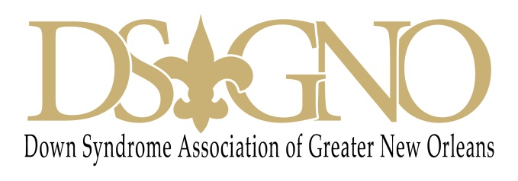

13th Annual Buddy Walk Event
October 29, 2016
Sponsorship Benefits
$5,000
Platinum Summit Level
- Special verbal recognition and logo placement on all multi-media promotions
- Special logo recognition on all printed materials and the DSAGNO website
- Color ad on promotional flyer
- Stage banner identification as a platinum corporate sponsor for Buddy Walk 2015
- VIP Buddy Walk attendance for unlimited guests
- Recognition and spotlight presentation at the event
- Onstage photo opportunity with guests by Buddy Walk photographer

$2,500
Esteemed Sponsor Level
- Logo placement on multi-media promotions
- Special logo recognition on all printed materials and the DSAGNO website
- Color ad on promotional flyer
- Stage Banner Identification as a lead corporate sponsor for Buddy Walk 2015
- Admission to Buddy Walk event for 30 guests
- Recognition and spotlight presentation at the event
- Photo opportunity with guests by Buddy Walk photographer

$1,000
DSAGNO Patron Level
- Identification as a supporter for the 2015 Buddy Walk event
- Special logo recognition on all printed materials and the DSAGNO website
- Color ad on promotional flyer
- Admit 20 guests to Buddy Walk event

$500
DSAGNO Friend Level
- Identification as a supporter for the 2015 Buddy Walk event
- Special logo recognition on all printed materials and the DSAGNO website
- Admit 15 guests to Buddy Walk event

$250
DSAGNO Buddy Level
- Identification as a supporter for the 2015 Buddy Walk event
- Special logo recognition at event
- Admit 10 guests

